Looker Studio Dashboard
To download Contents Under Pressure data, navigate to https://lookerstudio.google.com and click the blue “USE IT FOR FREE” button

From there, connect your Google account that has permissions to view the GA4 dashboard (connect with Cheryl Bodnar if you don’t have this access).

Once you’re logged in, you’ll first need to setup the connection between Google Analytics and Looker Studio. Click on “Create” and then “Data Source”
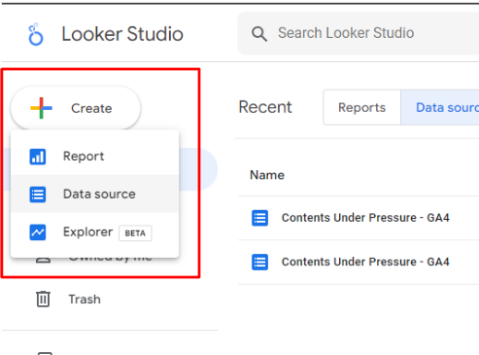

Then select “Google Analytics” from the Google Connectors list.
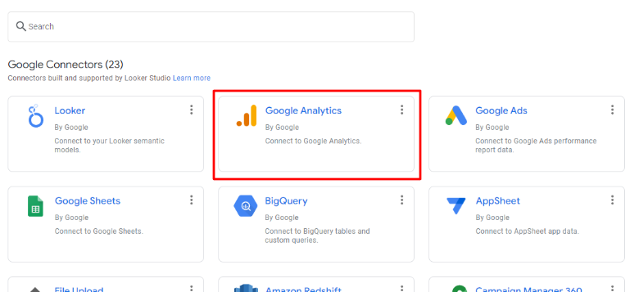
You’ll see a list of Accounts. Select “Engineering Education Research” and then the subsequent “Contents Under Pressure - GA4” property (with property ID 371147990). Then click the blue “Connect” button in the upper right.
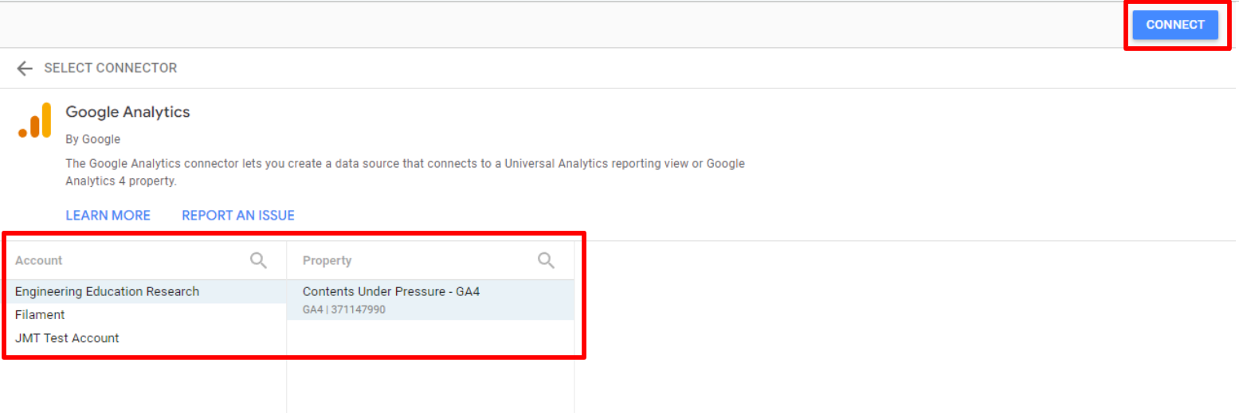

After connecting your Data Source, we need to create a new Explorer. Select “Create” and then “Explorer”
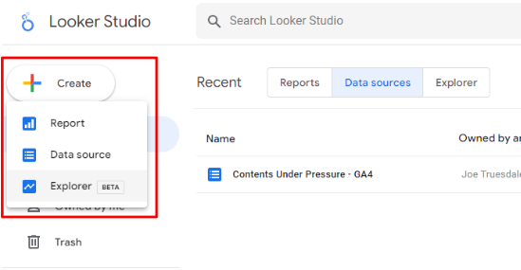
In the Data column on the right, select “Contents Under Pressure - GA4”
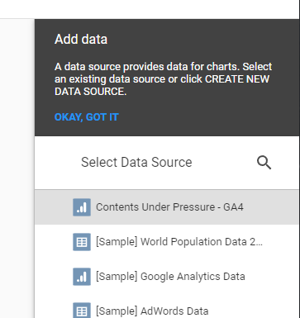

Click the “Untitled Explorer” title to give your Explorer a more descriptive file name.

Under the “Setup” tab on the right, find “Dimension” and remove “Event name.” Then select “Add dimension” and add the following:
- timestamp
- userId
- playMode
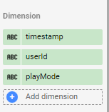
You can drag and drop these to appear in any order you prefer.

Next, move to the “Metric” section and remove “Views.” Then select “Add metric” and add the following:
- cardChoice
- cardIndex
- day
- sliderValue
- timeTaken
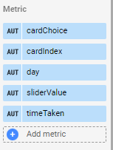
You can drag and drop these to appear in any order you prefer.

Next, ensure that the date range is set to the bounds you need for your data export. Under “Default date range” select “Custom” and then click the “Last 28 days (exclu…” to open up a calendar to select your start and end dates.
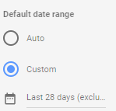
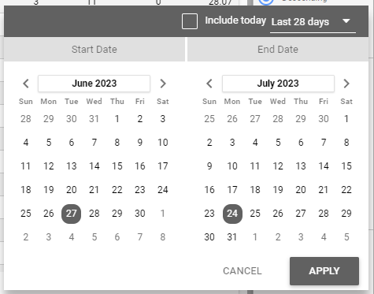

After clicking “Apply” your data should refresh automatically and only contain events that happened across that time period.

Finally, you can set the number of rows you want to see per page in this dashboard view. Under “Rows per Page” you can set it to “50,000”
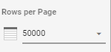

To export your data, click the three vertical dots just above your table on the right side and select “Export”
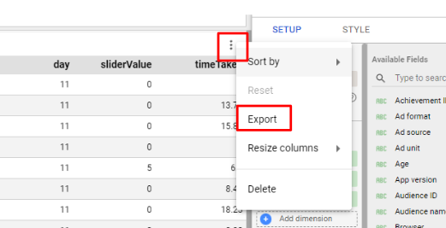

In the pop up window, name the report and keep the “CSV” option selected. Then click “Export”
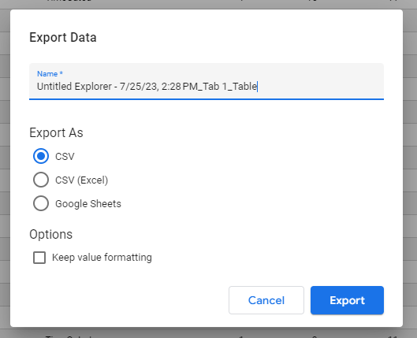

Anytime you want to go back to your previously created Explorers, simply click the “Explorer” tab and then click the name of the file you want to view.
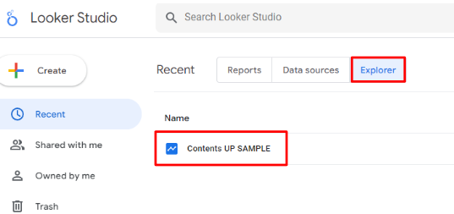

Microsoft Excel
When you have the multiple documents open in Excel, simply copy paste the data from the latter pages into the first download. Don’t copy over the headers, and don’t copy over the summation data in the final row of the document.

To move data around quickly, use hot keys. In the second/third documents, select cell 2A. This should be the timestamp of the first row of data, skipping the headers. While holding SHIFT and CTRL, press the right and down arrow keys each once to select all of the data. This will save you from click-n-dragging to select 5000 rows. Use CTRL+C and to CTRL+V copy paste data quickly too. You can also use us CTRL + arrow key to navigate to edges of matrices/vectors quickly.

Next you need to filter the data for “trash” entries. Find the filter tool in the Excel toolbar under the data tab. Click a column header to select the whole column and select the filter button to begin filtering.

I started with the Time Taken variable in Column G. Select the pull down menu to see all entries in the column. Deselect the (Select All) button, and select the 0.00 entry, and select the okay button. This shows only the data that took “zero” time. Does that sound right? Nope! So we are going to delete it. Select the cell immediately under the header and use the SHIFT + CRTL + down arrow to select all of the 0.00 time data. Right click over the highlighted data, and delete entire sheet row. Occasionally, you will delete a few thousand rows, which is computationally demanding. It takes time to delete a row and move the data up one and repeat. Excel will give you a warning if it takes significant time. If you ever come across this warning, consider, using the filter to copy the good data onto a new sheet instead of deleting the bad data.
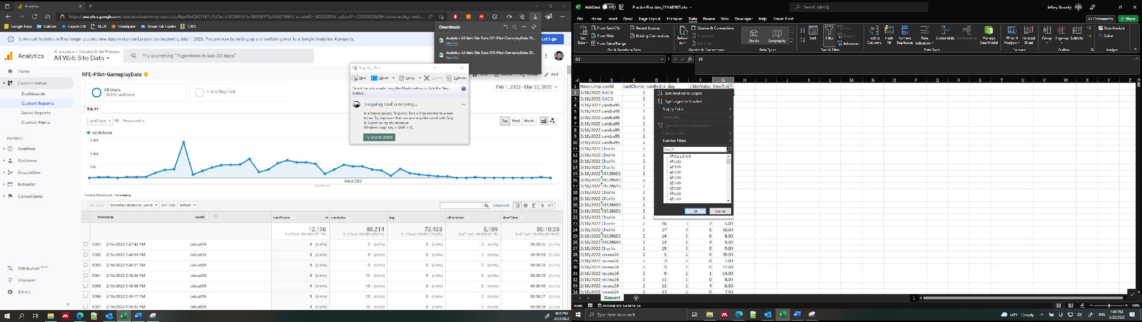

You continue this filtering process across all columns
- Days shall not exceed 15.
- Card index should exceed 21-22
- Unless you are doing moral reasoning work, we only want 0 slider values
- Card choices can only be 1 or 2.
- You can delete bogus UserIDs or copy desirable ones into a new sheet from here

Once you complete filtering bad data, you should organize data using sorting tools. Select the
select all button on the top left corner of the matrix. Next, select the Sort button from the toolbar. And a new menu will pop up.

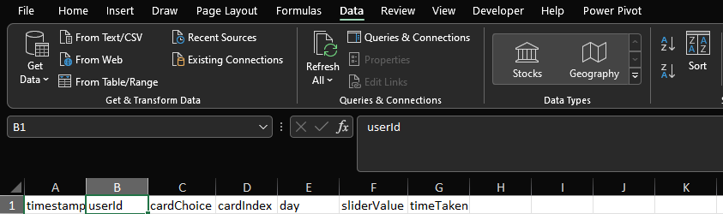

Sorting takes in a list of orders to follow sequentially, so be thoughtful how you enter this information. You can +Add Level to add additional sorting criteria. Add in time stamp last. This will help us identify what data to use if they played a level more than once. Make sure you select My data has headers to help with you organizing/labeling. Hit OKAY, and sort by things that look like numbers (the default).

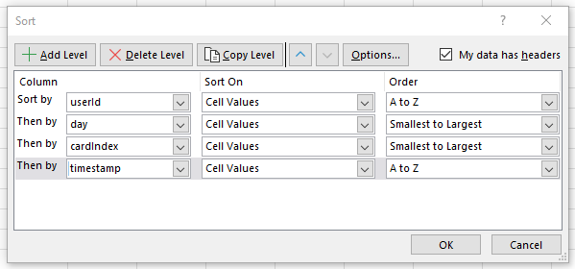

Next suggested step is looking for repeat attempts. In Column H (the next empty one), add a header for organization and enter in this text.

=IF(D2=D1,1,"")

This checks if the card index in your current row is equal to the card index above it. They should not be equal. If they are qual, then you may have found a repeat attempt. The second entry in the function is the output when the function is True. The third entry, which returns a blank but not empty cell, is when the function is False. You can right 0 here if the blank cell is hard to keep track of. Once you enter this into the second row, select the cell you just typed in and double click the bottom right corner of the cell to auto-populate downwards. This only works when the column to the left is already populated.

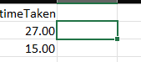

Use the filter to show only 1’s and investigate repeats. This filter and find method is all you need to start cleaning and organizing the data.

Goodluck!

ℹ️ Note from Filament to administrators:
It is recommended to keep the UA property within your account to ensure that the link between the UA tag on the game can still be associated with your GA account and the GA4 property’s dashboard, per this article from Google.

Google Analytics GA4 Dashboard - DEPRECATED
You can access old explorations in this menu or make a new exploration with + Create a new exploration

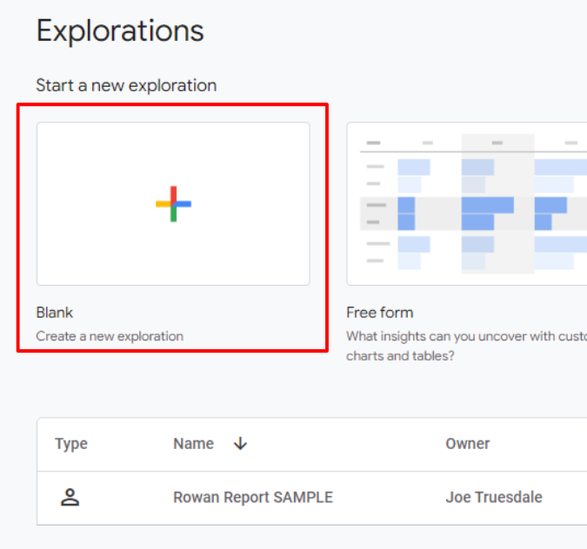

Next, you need to decide what data you want to export. There is a lot to pick from, but our typical data analysis looks at custom variables to look specifically at gameplay data. You can title your exploration in whatever manner that will help you stay organized. I named the example exploration “Contents UP SAMPLE.” In Contents Under Pressure, players need to have a gamertag called userId. I also like to look at timestamp to find people who reset their computer clocks. To add these identifiers to your report, select + next to DIMENSIONS and select “userId” and “timestamp.” Drag each of them into the ROWS section.
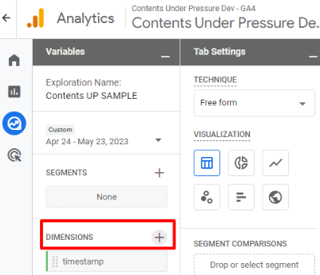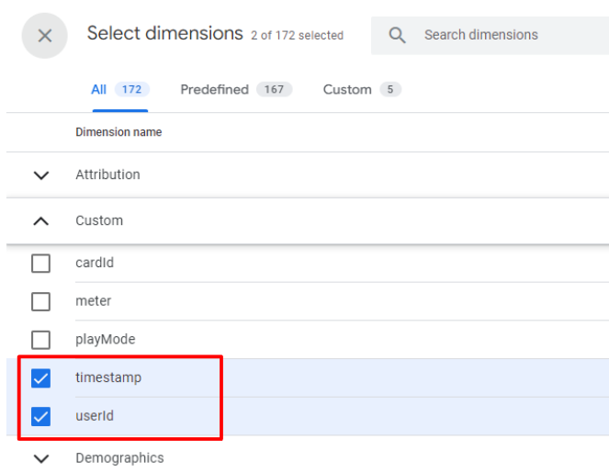
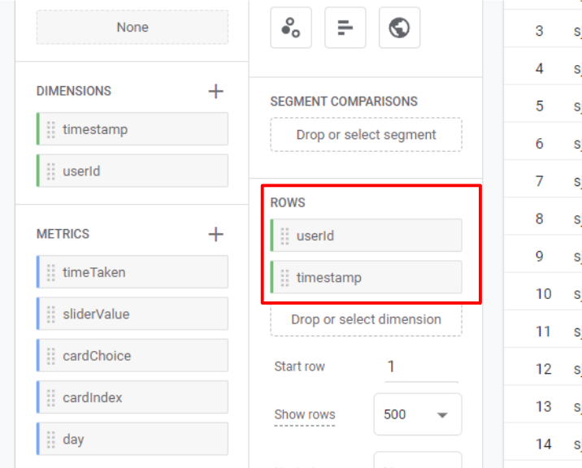

Next, you'll want to add the custom metrics. I typically go for five metrics: cardChoice, cardIndex, day, sliderValue, and timeTaken.

To add these identifiers to your report, select + next to METRICS and select all five in the list. Drag each of them into the VALUES section.
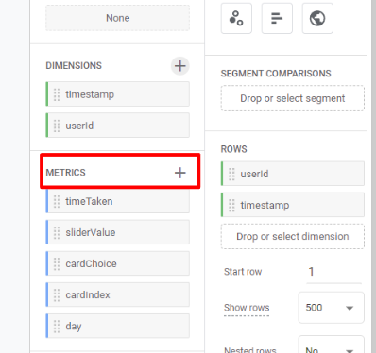
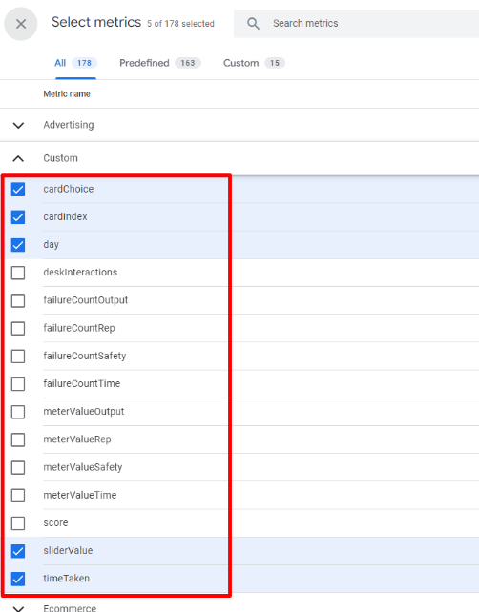
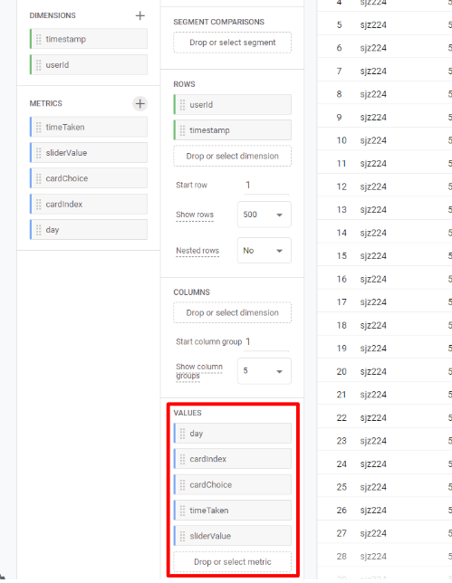

You can then select any of the column headers to set the sort order of the data (but this can also be done in Excel after you export the CSV).
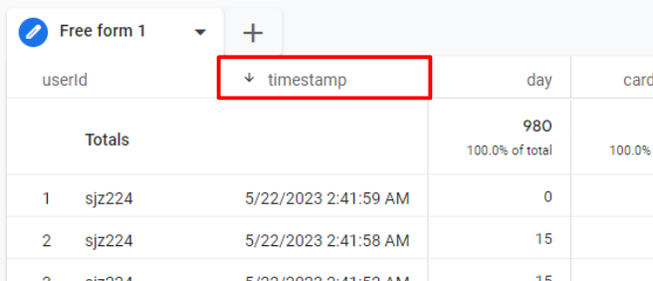

In the top left of the screen, you can change the calendar pull down window for when you are expecting data. I’d overshoot dates where possible to catch everything. Also, note that the export button is in the top right of the screen (as an arrow pointed down into a half-rectangle).
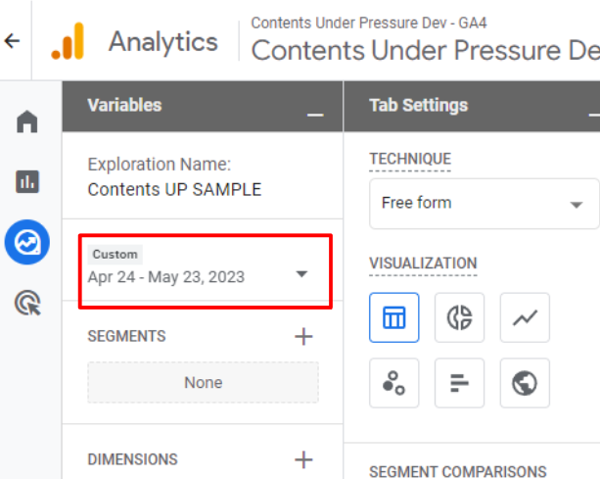

Since we are looking at intense numbers of students, you may need to increase the bounds of the export. Under the “Tab Settings” column, change show rows to 500. Google Analytics does not let you exceed this number in our version, so you may need to narrow filters down by date in order to get all expected data within each export. Also, make sure you scroll to the bottom of the list to affirm all rows have been exported.
